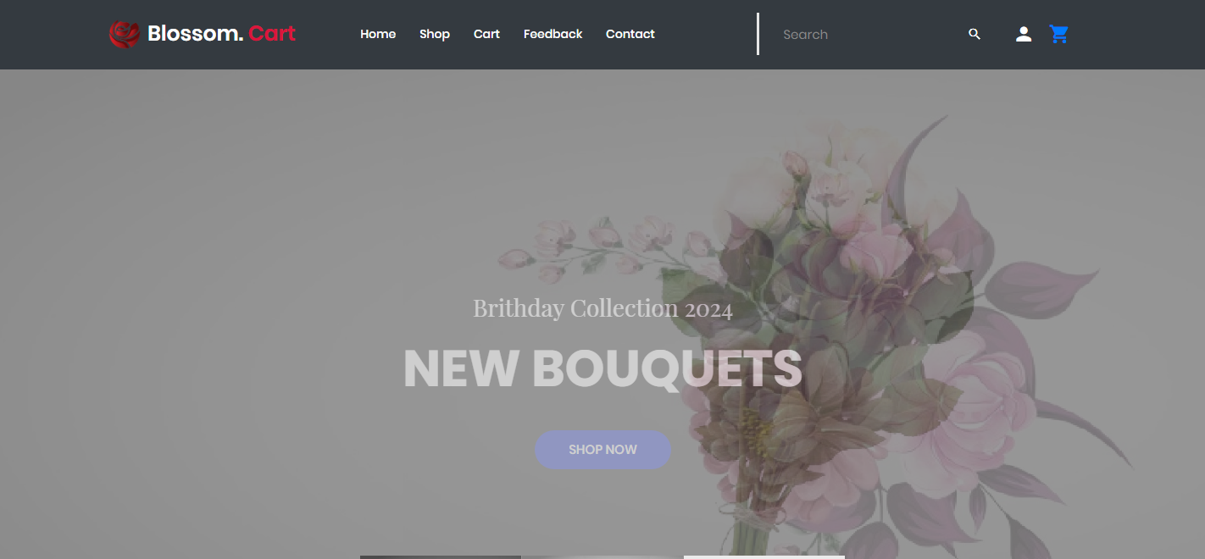

| **Supervisor** | SIR HARISS NASEER | |
| --- | --- | --- |
| **Batch** | 2301b2 | |
| **Group** | **A** | |
| **Serial No.** | **Enrollment Number** | **Student Name** |
| 1. | Student1451599 | MUHAMMAD AHMED IDRESS |
| 2. | Student1449717 | MUHAMMAD MOHSIN MUKHTIAR |
| 3. | Student1448755 | MUHAMMAD QSAIM MUSTAFFA |
| 4. | Student1448145 | EMANNUAL |
| 5. | Student1398610 | SYED MINHAJ UDDIN |
| 6. | Student1449714 | HASEEB AHMED |
|  |  |  |

**Problem Statement**

**The problem statement is attached separately in a file “online floral delivery.doc”**

**Standards plan:**

**Every code block must have comments.**

**The logic of the program needs to be explained. Proper documentation should be**

**maintained.**

**Complete Project Report along with synopsis, code and documentation should be**

**prepared.**

**Documentation:**

**No project is complete without documentation. In fact, it is one of the most**

**important activities during the development of a project. The documentation of an**

**ideal project will be in the form of a project report comprising of the following**

**documents:**

**Certificate of Completion.**

**Table of Contents.**

**Problem Definition.**

**Customer Requirement Specification.**

**Project Plan.**

**E-R Diagrams.**

**GUI Standards Document.**

**Interface Design Document.**

**Task Sheet.**

**Project Review and Monitoring Report.**

**Unit Testing Check List.**

**Final Check List.**

**Requirement Specification:**

Our client, java Florist wants the following actions to be implemented.

1. The application will have a web page which have links or option

home, My account, about flowers, view cart, ,florist registration

etc.

2. the home page will also have link for different occasions and

when the user clicks on any occasion the bouquets available

with that occasion would be displayed with there price.

3. If the user wants to book any bouquets he has to register

himself. At a time the user can book more than one bouquets. At

the time of booking the bouquets gets attached to cart and the

total price will be calculated.

4. The price would be paid through credit card.

5. After paying the money it should also collect the information to

whom the bouquet have to be delivered, their name, address,

phone no and the message.

6. For messages there would be dropdown list having all the

occasion in the list. According to the selected occasion

predefined messages will be displayed and the user can choose

one of them. Also he can write his own message in the text area

provided.

7. The bouquet will be delivered with in the five hour of the

booking. The working hour of the florist is morning 9 a.m to

evening 9 p.m. If the booking order is within the five hours of

working hour the bouquet will be delivered on the same day

otherwise it will be delivered on the next day.

8. Admin login should able to update and delete the bouquets

available, there price etc.

**ACKNOWLEDGEMENT:**

I am grateful to all of those with whom I have had the pleasure to work during this and other related projects. My Faculty (Sir Hariss Naseer) has provided me extensive personal and professional guidance and taught me a great deal about the project.

**SYNOPSIS:**

Bolosom Cart is your go-to online floral shop, specializing in delivering beautiful and fresh flowers right to your doorstep. Our website features a wide variety of floral arrangements, from elegant roses and vibrant tulips to exotic orchids and cheerful sunflowers. Each bouquet is crafted with care, using the highest quality blooms to ensure lasting beauty and fragrance.

Our user-friendly website makes it easy to browse through our diverse collection and select the perfect arrangement for any occasion. Whether you’re celebrating a special event, expressing gratitude, or simply brightening someone’s day, Bolosom Cart offers a seamless shopping experience.

In addition to our ready-made bouquets, Bolosom Cart also provides floral care tips and DIY arrangement ideas, so you can make the most of your flowers. Enjoy the convenience of fast and reliable delivery, and let us help you spread joy with the gift of fresh, stunning flowers. Visit Bolosom Cart today and find the perfect floral treat for yourself or a loved one!

**SITEMAP/ER DIAGRAM**

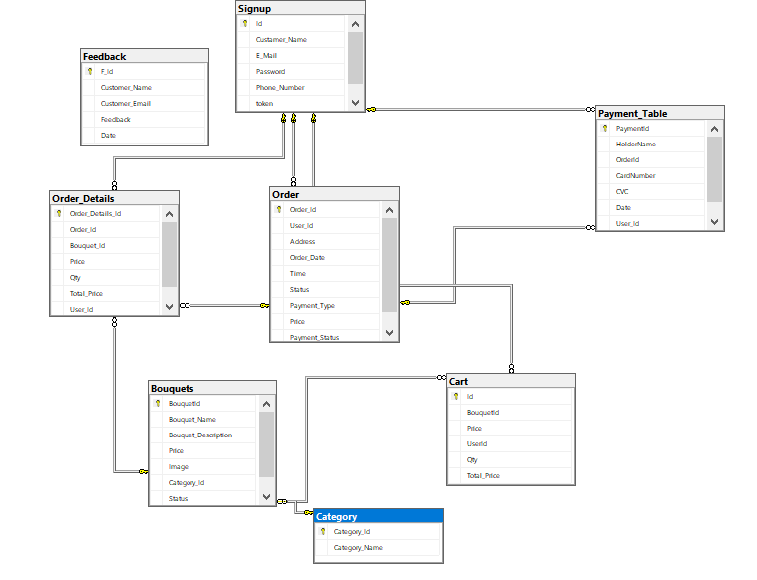

**WIREFRAMES**

**Navbar:**



**Categories:**

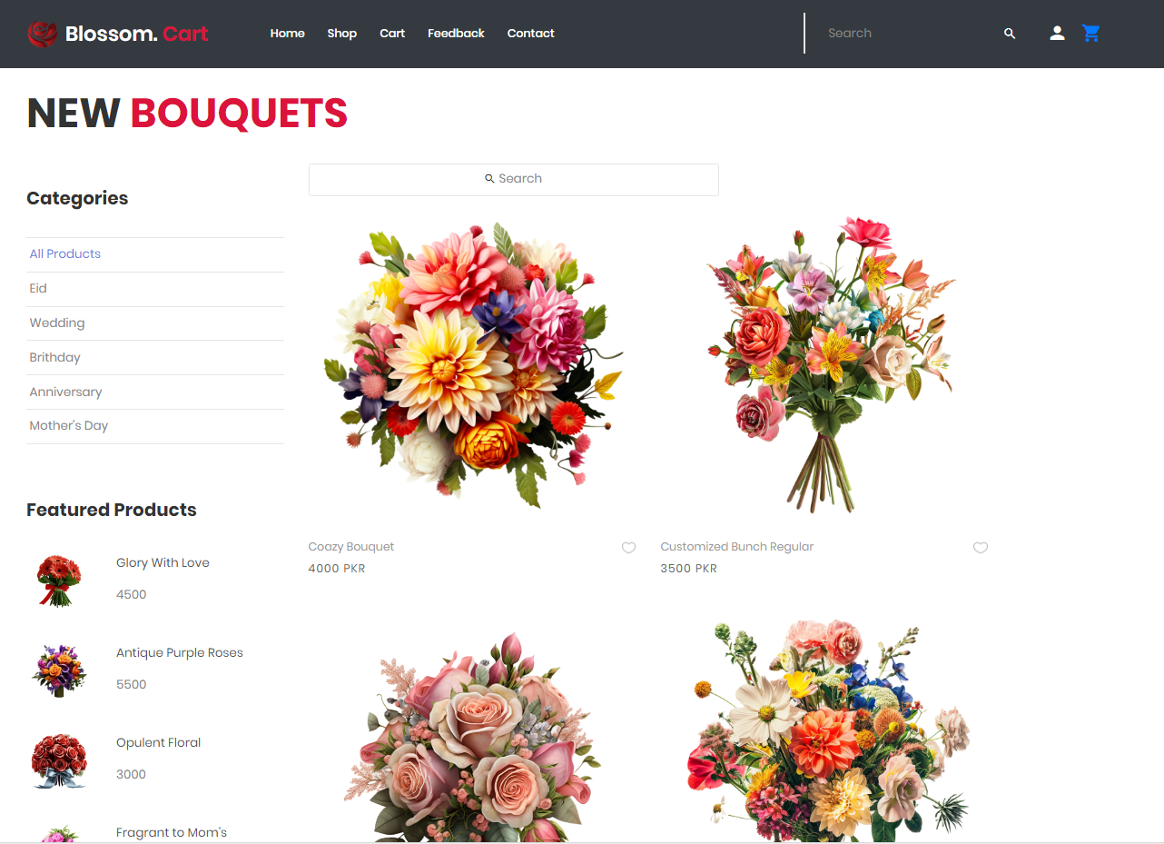

**Add to cart:**

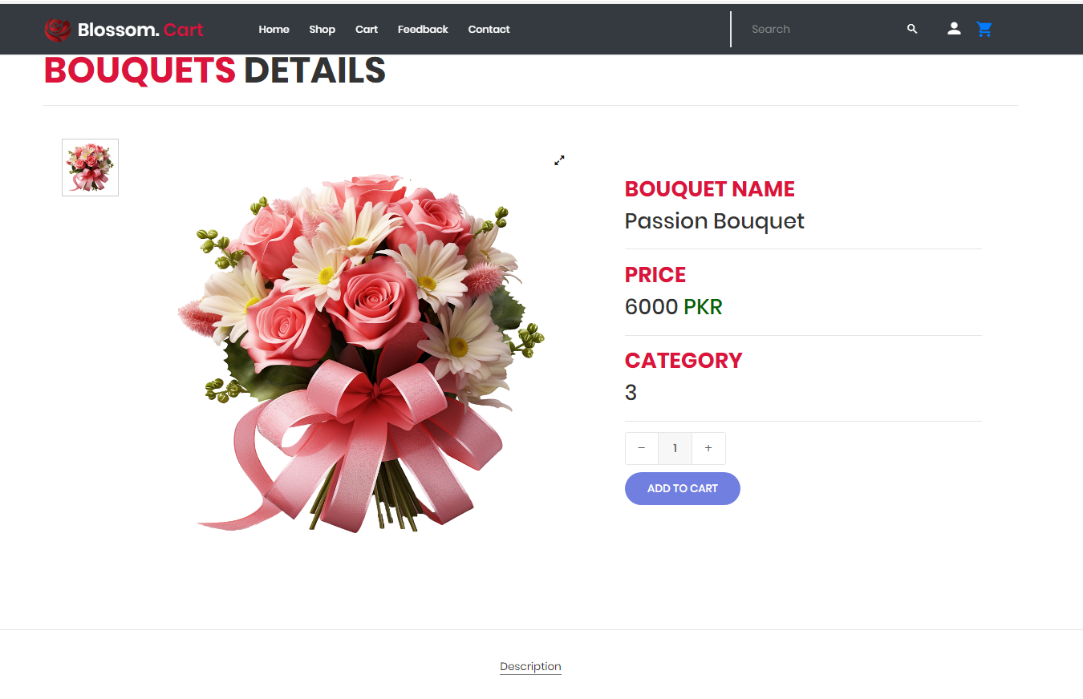

**Footer:**

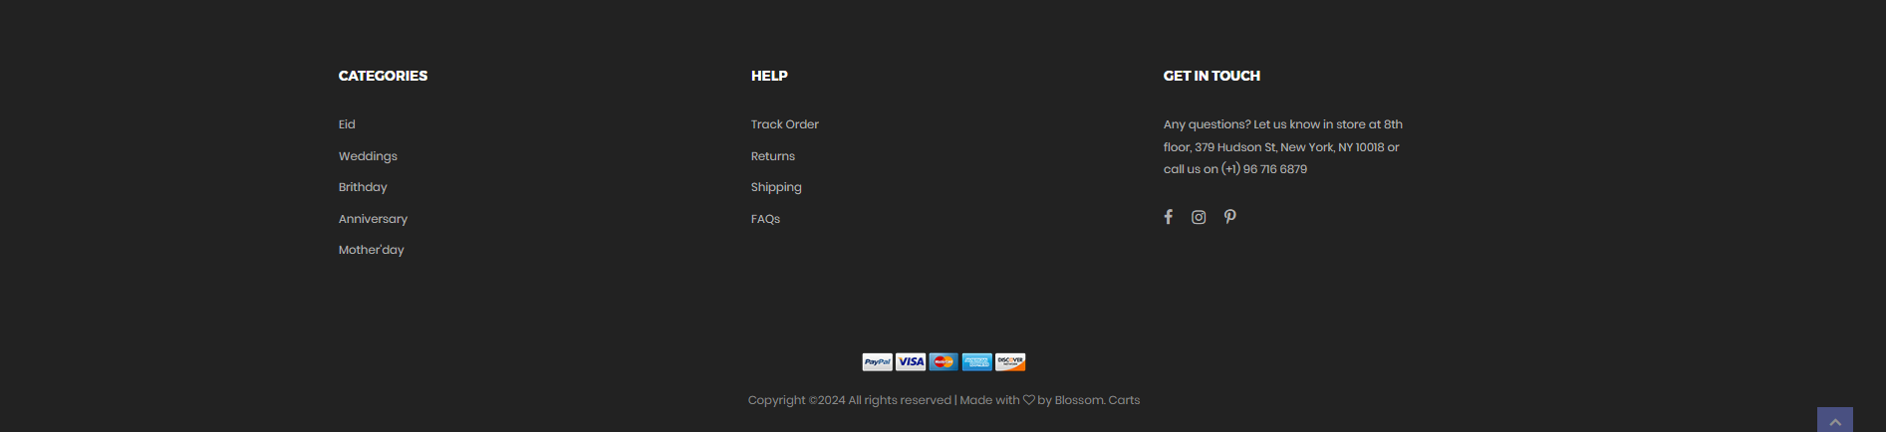

**Shop Pages:**

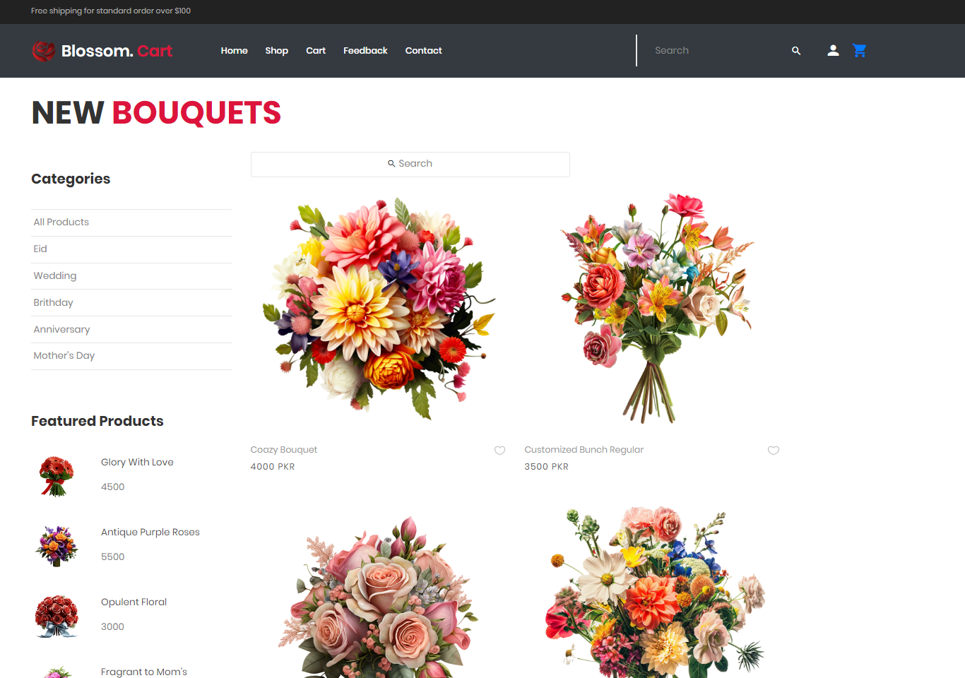

**Buy Now Pages:**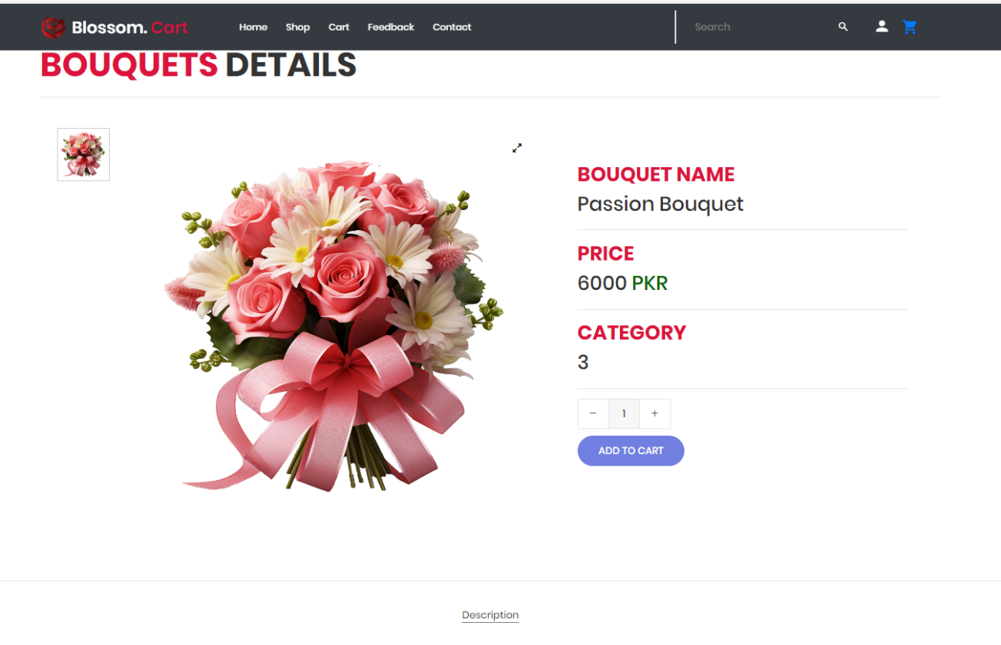

**A**

**A**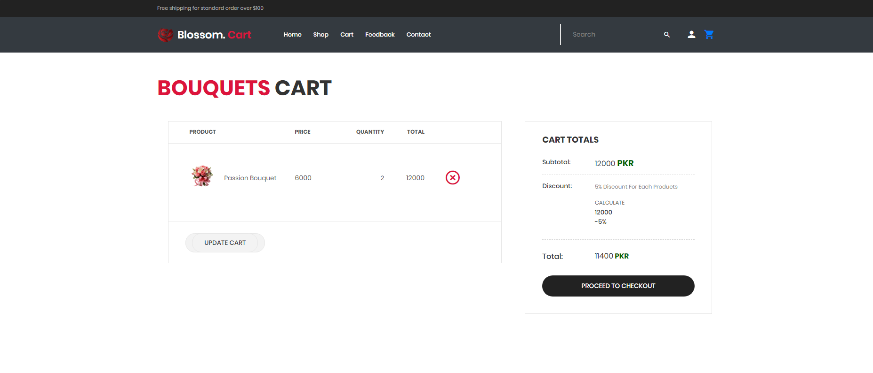

**Place order Pages:**

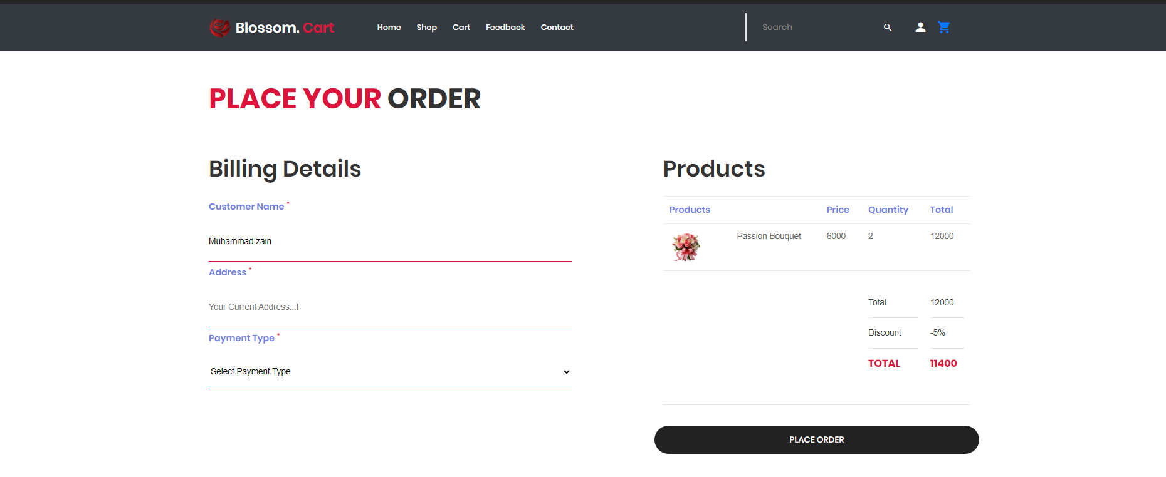

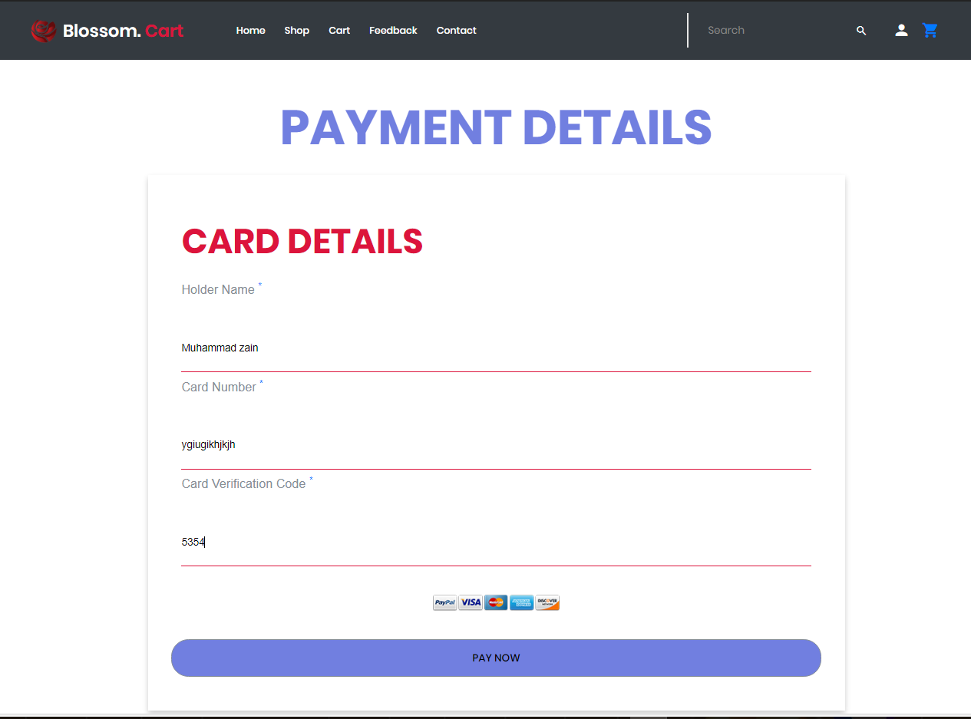

**Contact Page:**

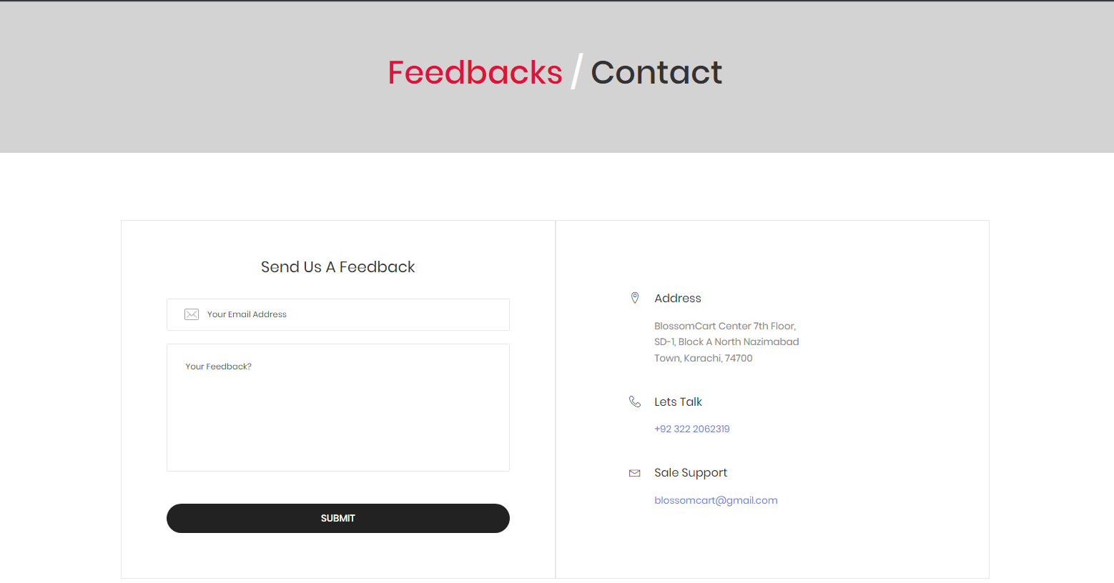

**Sign In Page:**

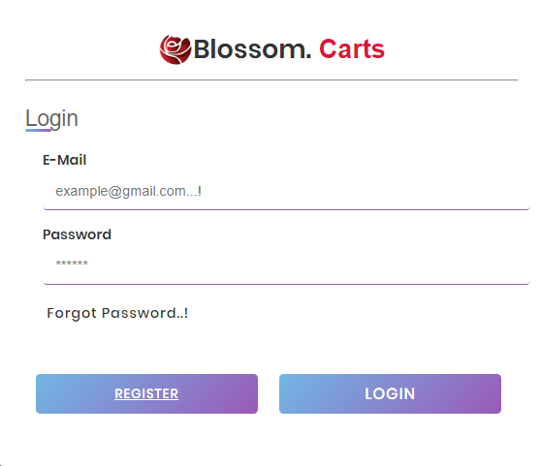

**Signup Page:**

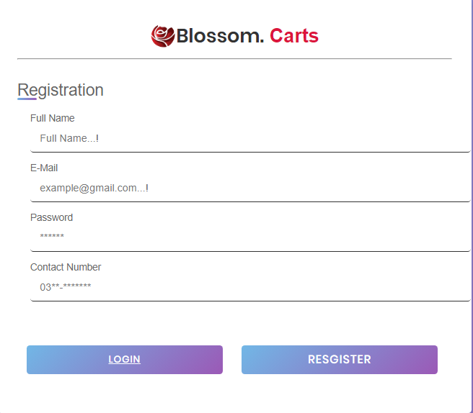

**Task Sheet Review User Pannel**

|  | | **Project title** | **Date of Preparation of Activity Plan** | | | |
| --- | --- | --- | --- | --- | --- | --- |
| No. | **Task** |  | Actual | Name | Status |
| Days |
| 1 | Home page | Blossom. Carts | 3 | Muhammad Ahmed | Complete |
| 2 | Shop page | Blossom. Carts | 3 | Muhammad Ahmed | Complete |
| 3 | Details page | Blossom. Carts | 2 | Muhammad Ahmed | Complete |
| 4 | Add to cart | Blossom. Carts | 1 | Muhammad Ahmed | Complete |
| 5 | Categories Pages | Blossom. Carts | 7 | Muhammad Ahmed | Complete |
| 6 | Search Pages | Blossom. Carts | 2 | Muhammad Ahmed | Complete |
| 7 | Checkout Page | Blossom. Carts | 3 | Muhammad Ahmed | Complete |
| 8 | Feedback Page | Blossom. Carts | 1 | Muhammad Ahmed | Complete |
| 9 | Login page  Signup page | Blossom. Carts | 2 | Muhammad Ahmed | Complete |
| 10 | Payment Page | Blossom. Carts | 1 | Muhammad Ahmed | Complete |
| 11 | Contact Page | Blossom. Carts | 1 | Muhammad Ahmed | Complete |
| 12 | My Cart | Blossom. Carts | 1 | Muhammad Ahmed | Complete |
| 13 | Forgot Mail | Blossom. Carts | 1 | Muhammad Ahmed | Complete |
| 14 | My Cart | Blossom. Carts | 1 | Muhammad Ahmed | Complete |

**Task Sheet Review Admin Pannel**

|  | | **Project title** | **Date of Preparation of Activity Plan** | | | |
| --- | --- | --- | --- | --- | --- | --- |
| No. | **Task** |  | Actual | Name | Status |
| Days |
| 1 | Home page | Blossom. Carts | 1 | Muhammad Ahmed | Complete |
| 2 | Order page | Blossom. Carts | 1 | Muhammad Mohsin | Complete |
| 3 | Shipped page | Blossom. Carts | 2 | Muhammad Mohsin | Complete |
| 4 | Trash Page | Blossom. Carts | 1 | Muhammad Mohsin | Complete |
| 5 | Add Products Pages | Blossom. Carts | 1 | Muhammad Mohsin | Complete |
| 6 | Edit + Delete Pages | Blossom. Carts | 2 | Muhammad Mohsin | Complete |
| 7 | Restore Page | Blossom. Carts | 2 | Muhammad Mohsin | Complete |
| 8 | Products list Page | Blossom. Carts | 1 | Muhammad Mohsin | Complete |
| 9 | Admin Login page | Blossom. Carts | 1 | Muhammad Ahmed | Complete |

**Summary:**

**Bolosom Cart is your go-to online floral shop, specializing in delivering beautiful and fresh flowers right to your doorstep. Our website features a wide variety of floral arrangements, from elegant roses and vibrant tulips to exotic orchids and cheerful sunflowers. Each bouquet is crafted with care, using the highest quality blooms to ensure lasting beauty and fragrance.**

**Our user-friendly website makes it easy to browse through our diverse collection and select the perfect arrangement for any occasion. Whether you’re celebrating a special event, expressing gratitude, or simply brightening someone’s day, Bolosom Cart offers a seamless shopping experience.**

**In addition to our ready-made bouquets, Bolosom Cart also provides floral care tips and DIY arrangement ideas, so you can make the most of your flowers. Enjoy the convenience of fast and reliable delivery, and let us help you spread joy with the gift of fresh, stunning flowers. Visit Bolosom Cart today and find the perfect floral treat for yourself or a loved one!**